Developing Audio Plugins with iPlug2 - A Beginners' Course

Episode 1

Hi, my name is Matthew, I have a company called Shameless Plugs, and I would like to welcome you to this beginners' course on how to start developing your own audio plugins, using the fantastic iPlug2 framework.

Before we start, I would like to stress the following:
We will be using freely available, zero-cost software, almost exclusively.
The only exception will be the Reaper Digital Audio Workstation, which follows a kind of shareware model, which means that you can, from a technical perspective, use it for as long as you want, without technical limitations, but you are expected to pay its extremely fair price of around $60 after no less than 60 days of "trial" use.
After those 60 days, the functionality of Reaper will NOT change, and payment is never enforced, but to continue using it legitimately, you should purchase a licence.

There are also, however, free Digital Audio Workstations available, so even this doesn't need to cost anything.
I, personally, love Reaper, and I happily paid its very small purchase price; it's well worth it.

So, the software side of developing plugins doesn't need to cost you a penny.
However, behind all those wonderful software products we'll be using, there are actual developers, who are actual human beings, often with actual families and actual bills to pay, who spent countless hours developing their wonderful software.
So, please, if you can, please donate, so they will feel encouraged to continue their wonderful work.

With that out of the way: let’s go!

The Prerequisites

- Python
- Git

Getting iPlug2

When you search the internet for iPlug2, you’ll find its source code residing on GitHub.
GitHub got its name from Git, which is a fantastic Source Control Management system.
There’s actually two distinct ways to get iPlug2’s code:
1. First, by downloading a zip file from GitHub. This is the easiest way, but it’s also rather limiting: the version you download is fixed, and cannot easily be kept up to date. So, in this course we’ll not be following that route.
2. The better way is to ‘clone’ the iPlug2 repository, which will establish a conceptual ‘connection’ if you will, allowing us to keep iPlug2 up to date, to switch to different branches, to revert back to older versions, etc.

Git itself is a command line utility, which would normally mean you would have to use it from the command prompt.
However, a wonderful, and free, ‘shell’ has been created around it, a GUI, that will make working with Git a breeze.
This

============================================================

First of all, when you're not testing actual audio or anything else DAW-related, I advise to always work in 'app' mode, rather than 'vst3' mode.
Much more comfortable and faster working that way:

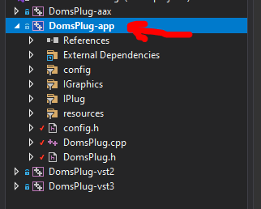

That line I copied, with the knob control in it, contained a vital word: kGain.

kGain is actually a *constant* (that's why there's a 'k' there, for 'konstant', lol: putting letters like that as a prefix is a convention, i.e. most developers will do this, and I advise you to do so too, although things will still work if you don't; it's just good practice to do so).
It being a 'konstant', a constant, means that it is defined as having a value that will never change for as long as the plugin is running / loaded.
In this case, it is a number, and it has the value 0, and it will have that value forever (or until you change it in the code and recompile).

So, you might ask: why not just put the number '0' instead of the word 'kGain'?
Well, that *would* work, but it would make maintaining your code infinitely harder.
Using a descriptive word (more formally: an *identifier*) there helps make your code way more readable, maintainable, understandable for other developers (which includes: future-you).

Now, to discover where kGain was defined, I want you to Ctrl + left-click on it (the cursor will already change to a hand when you just hit Ctrl, before clicking the mouse button).
This should make the editor jump to the spot where kGain is defined.
This will be in the header file, with the .h extension.
.h = definitions, declarations, etc.
.cpp = actual code that will be executed.

You will probably see something like this:

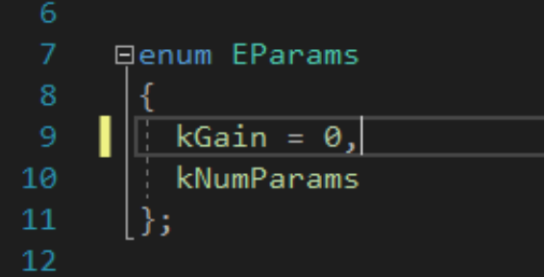

'enum' stands for enumeration, which means that this is a very simple list of identifiers ('kGain', 'kNumParams'), and they will have constant subsequeny values assigned to them, automatically.
So, in this case, it says kGain = 0, but that '= 0' isn't even strictly necessary.
If you omit it, it will automatically start at 0.
The identifiers thereafter will then automatically get subsequent values, so:
kGain is 0, and
kNumParams is 1 (because it follows the identifier with the value 0).

And lo and behold: kNumParams is actually the number of parameters: 1!
This is often done in enumerations like this: the last identifier will often have a name like 'kNumSomething', indicating the actual 'things' enumerated in it.

Now I want you to add a second parameter, like this:

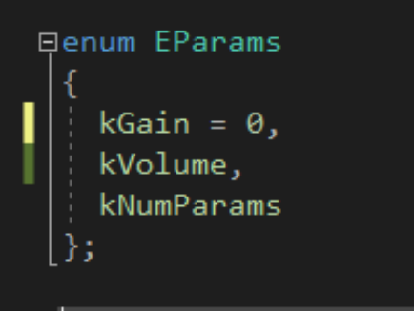

This will now mean that:
kGain = 0,
kVolume = 1 (because subsequent to 0), and
kNumParameters = 2 (because subsequent to 1).

And lo and behold once again: 2 parameters!

However, at this stage we haven't actually properly defined an actual new parameter yet: we've only defined the constant for it.
E.g., we haven't told the code yet what *kind* of parameters it is, what *range* it has, what default value it has, and so on.

We actually do that in the .cpp file:

This defines the parameter name, 'Volume' (it's what will become visible as a parameter in e.g. Reaper), its default value (0.0, here written as '0.' because Oli is an idiot, minimum and maximum values, the granularity ('step'), and the unit ('%').

This has now defined the parameter itself within the plugin, but this doesn't mean that there will be a control visible for it on the GUI yet.
(it is always important to mentally separate the plugin's functionality, its inner workings, from its GUI: those are complete separate things.
You can e.g. have parameters that aren't visible on the GUI, or things on the GUI that aren't parameters...
So it's up to us to make that link between the actual plugins functionality and its GUI.)

To make that connection, add something like the following, using the 'kVolume' identifier instead.
(I'm not going to discuss layout here (yet); you seem to have got that under control already)

This has now placed a knob on the GUI, and connected it to the relevant internal parameter.

The last thing to do is make sure the parameter does something to our audio.
In the code in .cpp, you will find the main audio processing loop 'ProcessBlock', with kGain being used.
Add a similar line for kVolume:

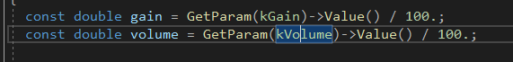

'const' means: it's a run-time constant, only used here locally inside of this ProcessBlock function (it doesn't exist outside of it).
'double' means 'double precision', which means it's a 64-bit floating point number ('single' doesn't exist I believe: that's called 'float', and it's 32 bits).
Most / all audio processing in iPlug2 is done in 64 bit.

Now that we have not only acquired the value of the gain parameter, but also of the volume parameter, we can use it inside of the loop that goes over all the samples:

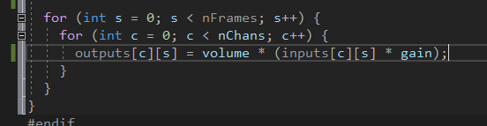

Later it will become clearer why I have laid out the formula like that (it's to do with the overdrive that will come a bit later).

This should now compile, and both parameters should work!

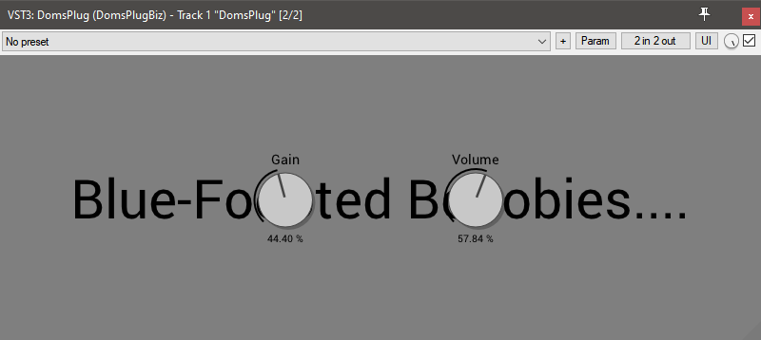

Tomorrow / later we will add a little overdrive to all of this, to make it useful!

===

By the way, there's a number of ways to find all occurrences of a certain identifier, like in this case kGain (which is extremely helpful when e.g. adding a parameter):

1. One way is clicking on the identifier in question and hitting Ctrl+Shift+F. This will bring up a special search dialog that lets you search through multiple files in the project / solution.
After it has finished searching, you can hit F8 to jump forwards between search results, and Shift+F8 to go backwards.
Please be aware that not all search results may be relevant though, as this is purely a dumb text search that is unaware of the meaning of what you're searching for.
Nonetheless, I use it all the time.

2. Another way is to actually slightly change the actual definition. I tend to temporarily put an 'x' in front, like this:

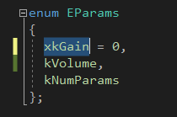

Now when you hit F5 to compile, of course it will fail, but that's exactly what you want: after compiling has finished with errors, hit F8 to jump to the first error!
(unfortunately this might bring up *warnings* as well, but if so then please skip those until you hit the first *error*).
You'll now see something like this:

...which is exactly right: kGain no longer exists, because you've renamed it (temporarily) to 'xkGain'.
This enables you to add / amend whatever code you want here (e.g. add a parameter), and then amend the identifier name:

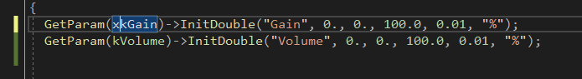

Hit F5 again, it will fail again (but at a later stage in the code), hit F8 to find the error, make additions / amendments, rinse and repeat, until it compiles successfully.

Then, later, you can change all 'xkGain' back to 'kGain' if you want.
I know this might feel as a bit of a hack, but it works and this, too, I use all the time.

